
TBA3241 Social Media Analytics
AY25/26 Semester 2
Final Report

Group 1
HAN LIHUI (A0265957J)
LI XUAN (A0287600E)
JERIN PAUL (A0227170M)
ZHANG LONGSHENG (A0287626N)

Table of Contents
Executive Summary 3
Data & Network Construction 3
Data Source 3
Data Cleaning 3
Network Construction 4
Network Analysis 5
Network Structure 6
Research Questions 8
Community Differences 8
Focus on Influence 11
Cross Party Influence 13
What-if Questions 17
Implications 20
Conclusion and Limitation 21
Reproducibility 22
References 23
Declare of AI tool usage 23
Appendix A 24

Executive Summary
This report analyses the Twitter Interaction Network of the 117th U.S. Congress to understand how political influence flows among legislators on social media. Using a directed, weighted network of 475 members and 13,289 edges, we address four research questions covering community structure, individual influence, cross-party information flow, and network resilience to node removal.
Key findings:
- Three cohesive party communities exist. Internal edge density exceeds external density by 4.9–8.3x for all three groups, confirming that party affiliation drives network clustering. Republicans exhibit higher per-node density and clustering, while Democrats dominate the densest inner core (54.2% of k=27 core vs 43.2% of the network).
- Influence is concentrated and asymmetric. Out-degree centralisation (0.38) far exceeds betweenness centralisation (0.07), indicating a few high-volume broadcasters rather than strategic brokers dominate outreach. Republicans hold 7 of the top 10 Viral Centrality positions; GOPLeader uniquely combines the highest betweenness (0.073) and eigenvector centrality.
- 77% of edges stay within the same party. Strong ties are even more partisan (80% within-party). No articulation points exist, yet a small set of cross-party bridgers carry disproportionate weight.
- The network is resilient to targeted removal. Removing the top 15 influencers reduces edges by 12% but barely changes the largest strongly connected component (98.5% intact), demonstrating distributed redundancy.

Data & Network Construction

Data Source
This study uses the Twitter Interaction Network for the U.S. Congress, obtained from the Stanford Network Analysis Project (SNAP). The dataset consists of publicly available Twitter interactions among members of the 117th U.S. Congress, originally collected via the Twitter API (Tweepy) as of 9 June 2022 (Fink, Omodt, Zinnecker, & Sprint, 2023).

Data Cleaning

Tweets created outside the common observation window (9 February to 9 June 2022) were excluded. Members tweeting fewer than 100 times during this window were also excluded (Fink et al., 2023). The final dataset contains 475 active members and 13,289 directed edges.

Two forms of sampling bias are acknowledged:

Activity bias – less-active members are excluded, over-representing highly engaged legislators.

Temporal bias – the four-month snapshot may not reflect long-term stable interaction patterns.

Network Construction
Interactions (retweets, replies, mentions, quote tweets) were counted for each directed pair and normalised by the source node’s total tweet count to produce an influence probability edge weight (Fink et al., 2023):

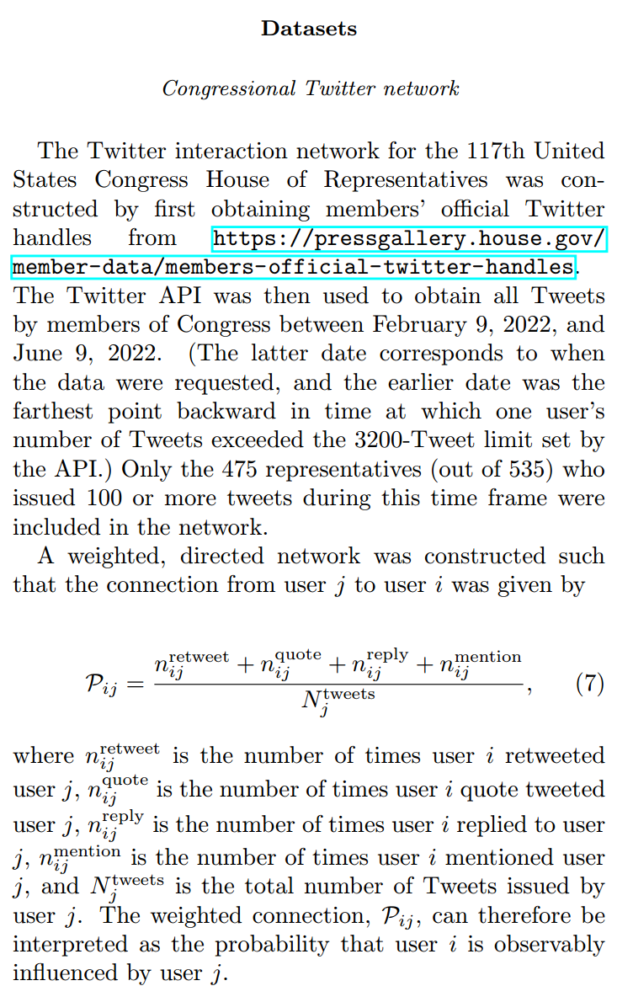
Figure 1. Excerpt from research paper describing calculation used for edge weightage
The network is directed (influence is asymmetric), weighted (by probability), and unimodal (Congress members only). All 13,289 edges carry a non-zero weight.
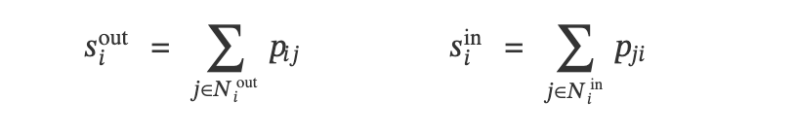
Degree and strength. Out-degree is the number of distinct members a node directs edges toward; in-degree is the number directing edges toward it. In a weighted network, degree alone does not capture interaction intensity. Strength (Barrat et al., 2004) addresses this by summing edge weights instead of counting edges.
Viral Centrality (VC) (Fink et al., Physica A, 2023) is a cascade-based influence measure. The dataset authors published the algorithm alongside the network data; we ran it on the edge weights to compute each node’s VC score. It simulates an Independent Cascade (IC) process: starting from seed node i, each active node u activates each inactive neighbour v with probability p_uv; the process repeats until no new activations occur. VC is the expected number of nodes activated, normalised by network size:

Key concepts and definitions used in this report:

Term | Definition
Out-degree | Number of distinct members a node directs edges toward
In-degree | Number of distinct members directing edges toward a node
Out-strength | Sum of edge weights on outgoing edges (total broadcasting intensity)
In-strength | Sum of edge weights on incoming edges (total received influence)

Network Analysis

Network Structure

Metric | Value
Nodes | 475
Directed edges | 13,289
Average in/out-degree | 27.98
Average edge weight | 0.0058
Graph density | 0.059
Reciprocity | 0.46
Weakly connected components | 1
Strongly connected components | 7
Largest SCC size | 469 / 475 (98.7%)
Diameter (largest SCC) | 6
Average path length (SCC) | 2.35 hops
Average clustering coefficient | 0.30

The network is weakly connected and nearly strongly connected (98.7% of nodes in the largest SCC). The short average path (2.35 hops) and high clustering (0.30, vs ~0.06 expected in a random graph of equivalent size and density) identify this as a small-world network. A reciprocity of 0.46 means nearly half of influence ties are mutual.
Party | Nodes | Share
Democrat | 254 | 53.5%
Republican | 220 | 46.3%
Independent | 1 | 0.2%

Chamber | Nodes | Share
House | 383 | 80.6%
Senate | 92 | 19.4%
House | 383 | 80.6%

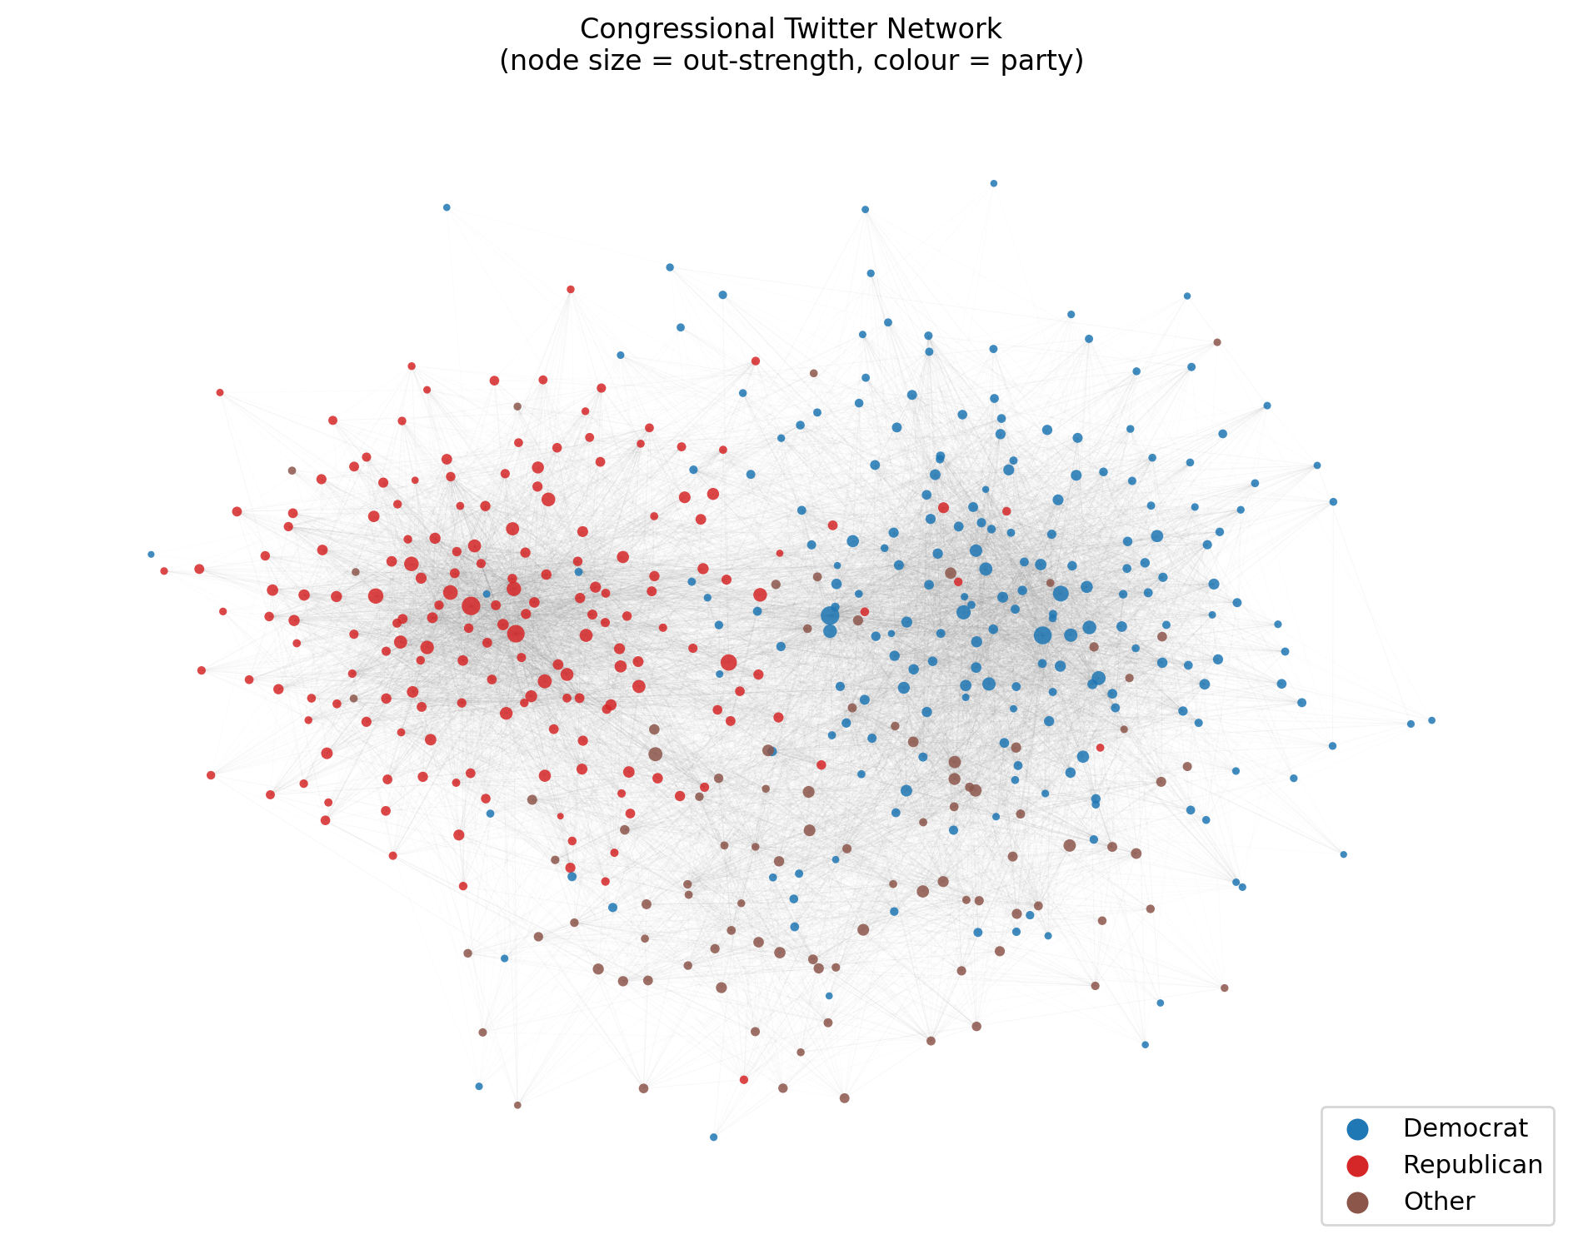

Research Questions

RQ1: Community Differences
How can Congress members be categorised on Twitter, and how do these groups differ from one another? Is the network centralised around a few dominant members?

Q1.1–Q1.2: Categorisation and Community Differences
Districts / states
Approach. We define communities using party affiliation as an exogenous attribute, grounded in the concept of homophily: the tendency for nodes to form ties with similar others. Party is the strongest measurable similarity attribute in this dataset. We then validate these attribute-defined groups structurally.
Cohesion test. For each party group, we computed the directed edge density within the group and the directed edge density between the group and all other nodes. A group is considered cohesive if its internal density substantially exceeds its external density.
Community | Size | Internal density | External density | Ratio
Democrat | 205 | 0.1066 | 0.0217 | 4.9x
Republican | 178 | 0.1388 | 0.0167 | 8.3x
Other | 92 | 0.1696 | 0.0271 | 6.3x

All three groups pass the cohesion test by a wide margin. Republicans have the highest internal density (0.139) and the largest ratio (8.3x), indicating the tightest within-group connectivity.
Per-community structural profiles:

Metric | Democrat | Republican | Other
Nodes | 205 | 178 | 92
Internal edges | 4,457 | 4,374 | 1,420
Avg degree (directed) | 43.5 | 49.1 | 30.9
Avg clustering coefficient | 0.362 | 0.457 | 0.412
Avg edge weight | 0.00514 | 0.00693 | 0.00578
Reciprocity | 0.462 | 0.499 | 0.525

Republicans exhibit higher average degree (49.1 vs 43.5), clustering (0.457 vs 0.362), average edge weight (0.0069 vs 0.0051), and reciprocity (0.50 vs 0.46) than Democrats. This indicates that Republican members interact more frequently and mutually within their party block. The Other group, despite being smallest, shows the highest reciprocity (0.525), likely reflecting a mix of Senate and independent members who actively engage with each other.

K-core decomposition. The k-core of a graph is the maximal subgraph in which every node has degree at least k. Iteratively increasing k peels away less-connected nodes, revealing the densest inner core.
At k=27, 201 nodes remain:
Party | In k=27 core | Share of core
Democrat | 109 | 54.2%
Republican | 88 | 43.8%

Democrats are overrepresented in the inner core by 11 percentage points (54.2% vs 43.2%), suggesting broader structural coordination across a larger group. Republicans, while having higher per-node density, concentrate their tight connectivity in a smaller, denser cluster rather than a broad backbone.

Q1.3–Q1.4: Network Centralisation
Approach. The centralisation index measures how much the network’s centrality distribution resembles a star graph (maximum centralisation = 1) versus a uniform distribution (centralisation = 0). We computed three variants on the directed graph.
Centralisation type | Value | Interpretation
In-degree | 0.2094 | Moderate: some members attract many more incoming ties than average
Out-degree | 0.3848 | High: a few members broadcast to far more peers than average

Out-degree centralisation (0.38) is the dominant signal: a small number of high-volume broadcasters drive a disproportionate share of outgoing ties. The node with the highest out-degree is SpeakerPelosi (210 outgoing edges), followed by GOPLeader (195).
Betweenness centralisation is low (0.07), indicating that the network is not funnelled through a few brokers. This is consistent with the small-world structure: many alternative shortest paths exist, so no single node is an essential bottleneck.

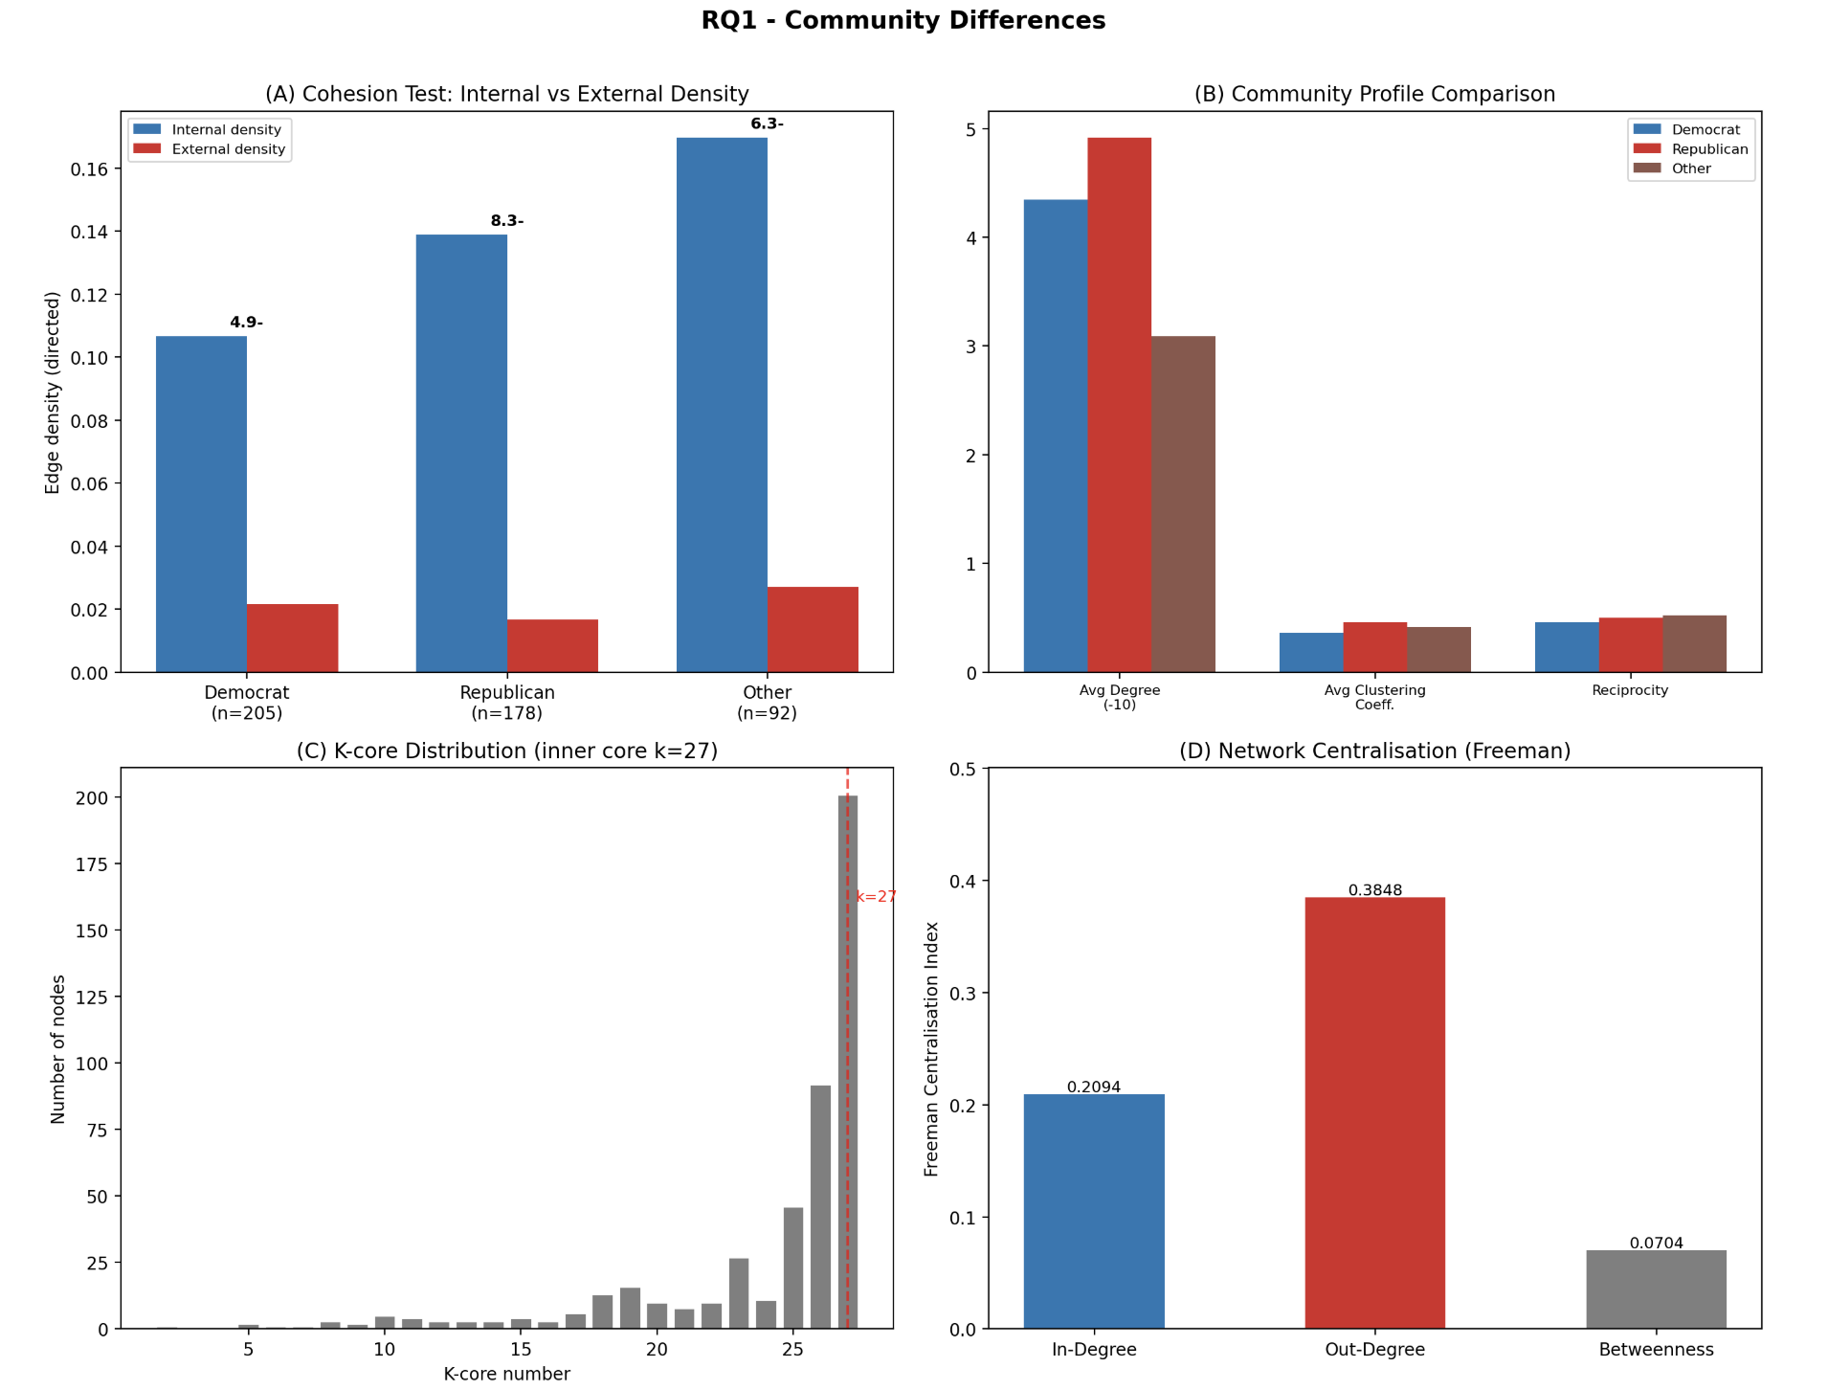

RQ1 Community
Figure 2 – RQ1 summary. (A) Cohesion test: all three party groups have internal density far exceeding external density. (B) Community profiles: Republicans have higher average degree, clustering, and reciprocity. (C) K-core distribution with inner core at k=27. (D) Centralisation indices.

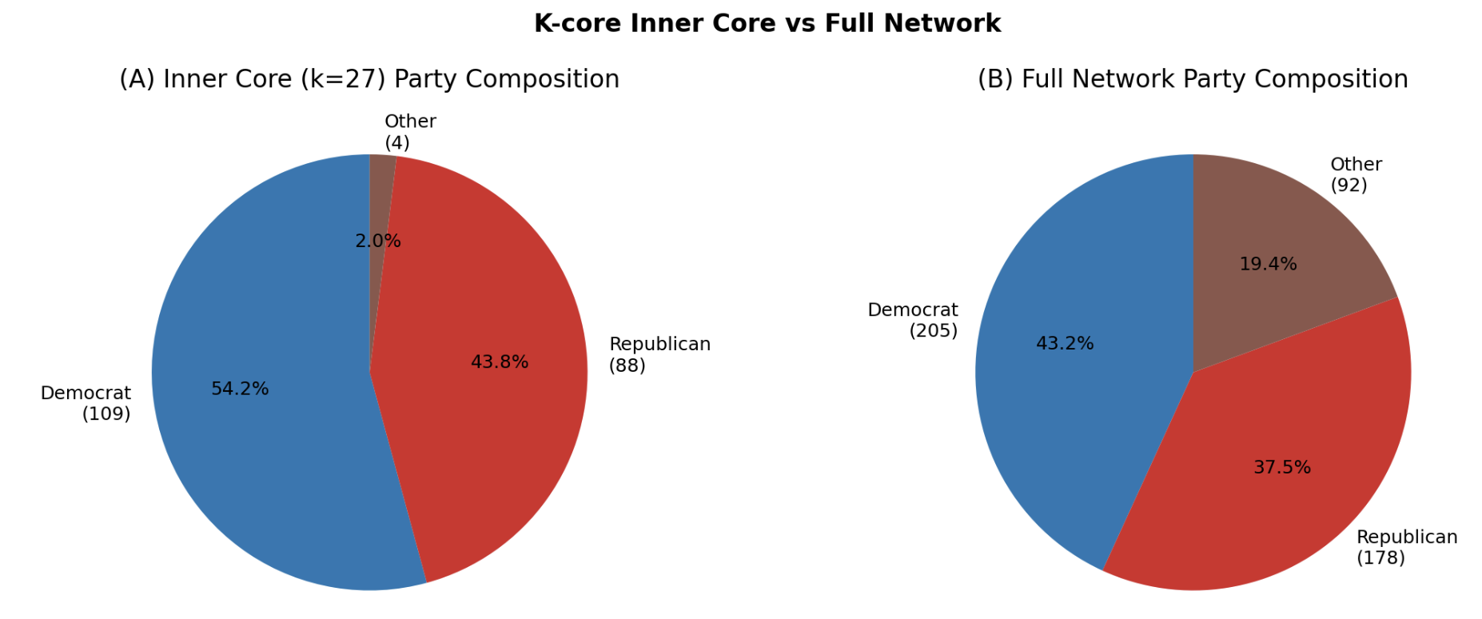

K-core Party
Figure 3 – K-core inner core (k=27) party composition vs full network. Democrats are overrepresented in the inner core (54.2% vs 43.2%).

RQ1 Conclusion:

1. Party affiliation defines three cohesive communities (internal density 4.9–8.3x external), validated structurally, not just by metadata labels.

2. Republicans form the tighter community (higher density, clustering, reciprocity, edge weight); Democrats form the broader structural backbone (overrepresented in the k=27 inner core).

3. The network is centralised by broadcasting volume (out-degree centralisation = 0.38) rather than by brokerage (betweenness centralisation = 0.07), meaning influence spreads through many high-volume posters, not through a few gatekeepers.

Focus on Influence
Who are the most influential members, and is influence balanced across parties?
This section addresses: - Q2.1: Who are the most influential users, and why? - Q2.2: Is there an imbalance of influence where influence is not reciprocated? - Q2.3: Are the influential users balanced across parties?

Q2.1: Most Influential Members
Approach. We ranked all 475 nodes by six centrality measures (degree, closeness, betweenness, eigenvector) plus out-strength and in-strength (weighted degree). We also computed Viral Centrality (VC), a cascade-based measure from the dataset paper (Fink et al., 2023) that uses edge weights as Independent Cascade transmission probabilities and estimates how many members a node can activate through the network. VC connects to the cascade model and SIR-style epidemic thinking.
Rank | Member | Party | VC | Betweenness | Out-Strength
1 | SteveScalise | Republican | 1.146 | 0.013 | 0.935
2 | SpeakerPelosi | Democrat | 1.112 | 0.041 | 0.944
3 | RepBobbyRush | Democrat | 1.007 | 0.027 | 0.869
4 | GOPLeader | Republican | 0.98 | 0.073 | 0.827
5 | RepJoeWilson | Republican | 0.81 | 0.005 | 0.695
6 | RepJamesComer | Republican | 0.784 | 0.001 | 0.603
7 | RepMarkTakano | Democrat | 0.781 | 0.002 | 0.65
8 | RepBobGood | Republican | 0.687 | 0.001 | 0.541
9 | RepCloudTX | Republican | 0.674 | 0 | 0.526
10 | RepFranklin | Republican | 0.646 | 0.017 | 0.518
SteveScalise (Republican Whip) and SpeakerPelosi rank 1st and 2nd. GOPLeader (Kevin McCarthy) holds the highest betweenness (0.073) and eigenvector centrality in the network, identifying it as a structural broker – not the loudest broadcaster, but the most strategically positioned node.
Top 15 by Betweenness (separate ranking) is led by GOPLeader (0.073), SpeakerPelosi (0.041), LeaderHoyer (0.030), and RepBobbyRush (0.027). These are members who sit on many shortest paths between other pairs, giving them potential gatekeeping power.

Q2.3: Party Balance Among Top Influencers
Tier | Democrat | Republican | Other
Top 10 by VC | 3 (30%) | 7 (70%) | 0
Top 20 by VC | 6 (30%) | 13 (65%) | 1
Top 50 by VC | 16 (32%) | 28 (56%) | 6

Republicans are consistently overrepresented in top influence tiers. Democrats make up 43.2% of the network but only 30% of the top 10 and 32% of the top 50 by Viral Centrality. This disparity reflects the Republican community’s higher per-node density and edge weight, which amplify cascade propagation within their tighter cluster.

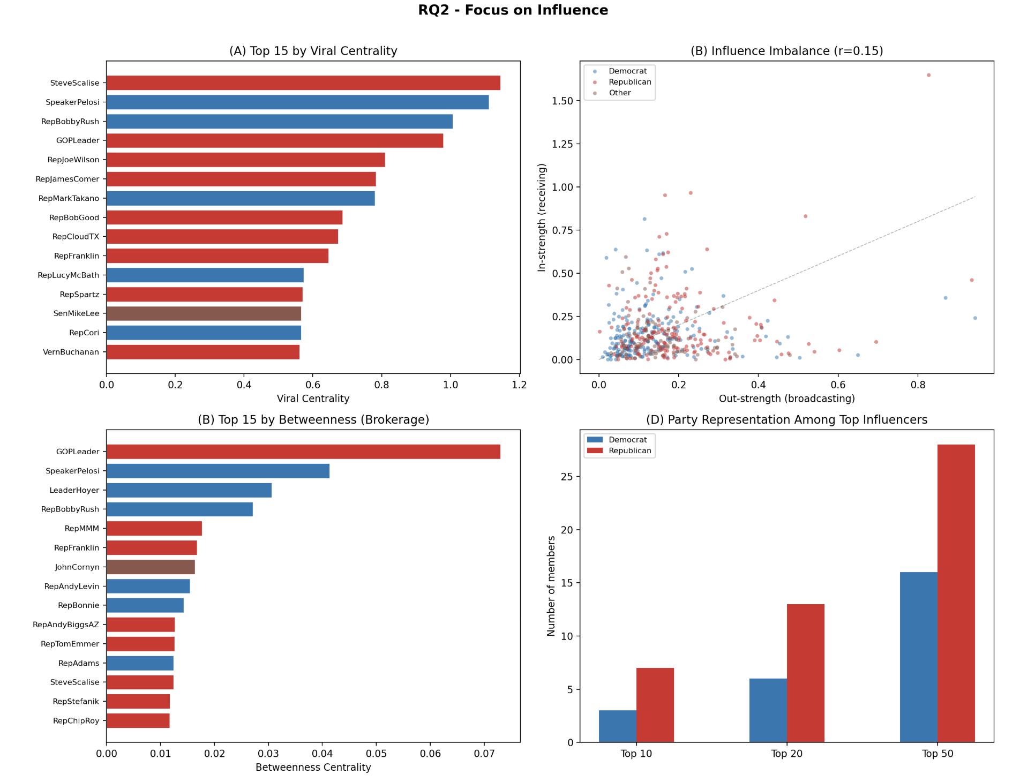

RQ2 Influence
Figure 4 – RQ2 summary. (A) Top 15 by Viral Centrality, coloured by party. (B) Out-strength vs in-strength scatter: low correlation (r=0.15) reveals broadcasting/receiving asymmetry. (C) Top 15 by betweenness centrality. (D) Party representation across top-N tiers.

RQ2 Conclusion: 1. Top influencers mirror real-world leadership roles: party whips, speakers, and floor leaders dominate both VC and betweenness rankings, validating that network centrality reflects institutional power. 2. Influence is asymmetric: out-strength and in-strength correlate weakly (r=0.15). High-volume broadcasters (SpeakerPelosi, SteveScalise) are not necessarily the most-engaged-with members (GOPLeader has the highest in-strength). 3. Republicans dominate top influence tiers (70% of top 10 by VC), despite being 37.5% of the network. Their tighter community structure amplifies cascade spread per node.

Cross Party Influence

Q3.1 + Q3.3: Within-Party vs Cross-Party Influence
Approach. We classified every directed edge as within-party or cross-party and computed shares by both edge count and total edge weight. We also classified edges into strong ties (weight above the median, 0.0037) and weak ties (weight at or below the median), following the strong/weak tie framework (Granovetter, 1973).
Measure | Within-party | Cross-party | Measure
By edge count | 77.1% (10,251) | 22.9% (3,038) | By edge count
By edge weight | 79.5% | 20.5% | By edge weight
Strong ties | 80.0% within | 20.0% cross | Strong ties
Weak ties | 74.3% within | 25.7% cross | Weak ties

The network exhibits strong homophily: 77–80% of all influence stays within party. Strong ties are even more partisan (80% within-party), consistent with the prediction from Granovetter’s strength of weak ties theory that strong ties cluster inside communities while weak ties are more likely to bridge across groups.

Party-to-party directed flow (Democrat and Republican only):
Source | Target | Edges | Share of D/R edges
Democrat | Democrat | 4,457 | 44.70%
Republican | Republican | 4,374 | 43.90%
Democrat | Republican | 589 | 5.90%
Republican | Democrat | 540 | 5.40%

Cross-party flow is roughly symmetric: Democrats send 589 edges to Republicans; Republicans send 540 to Democrats.

Q3.2: Bridging Nodes
Approach. We checked for articulation points: nodes whose removal would disconnect the undirected graph. We also identified cross-party bridgers by ranking nodes on total cross-party edge weight (sum of incoming + outgoing weights to/from other parties), combined with betweenness centrality.
Articulation points: 0. The network has no single point of failure – it remains connected even if any individual node is removed. This confirms structural resilience.
Top 5 cross-party bridgers:

Rank | Member | Party | Cross-party weight | Betweenness
1 | janschakowsky | Other | 0.571 | 0.004
2 | RepJoeWilson | Republican | 0.53 | 0.005
3 | SpeakerPelosi | Democrat | 0.371 | 0.041
4 | SenWarren | Other | 0.335 | 0.008
5 | SenatorCardin | Other | 0.317 | 0.004

“Other”-labelled members (often Senators or independents) appear prominently because they bridge between both major parties by definition. Among clearly partisan members, RepJoeWilson (Republican) carries the most cross-party weight, and SpeakerPelosi (Democrat) combines high cross-party weight with high betweenness, making her the most structurally significant Democrat bridge.

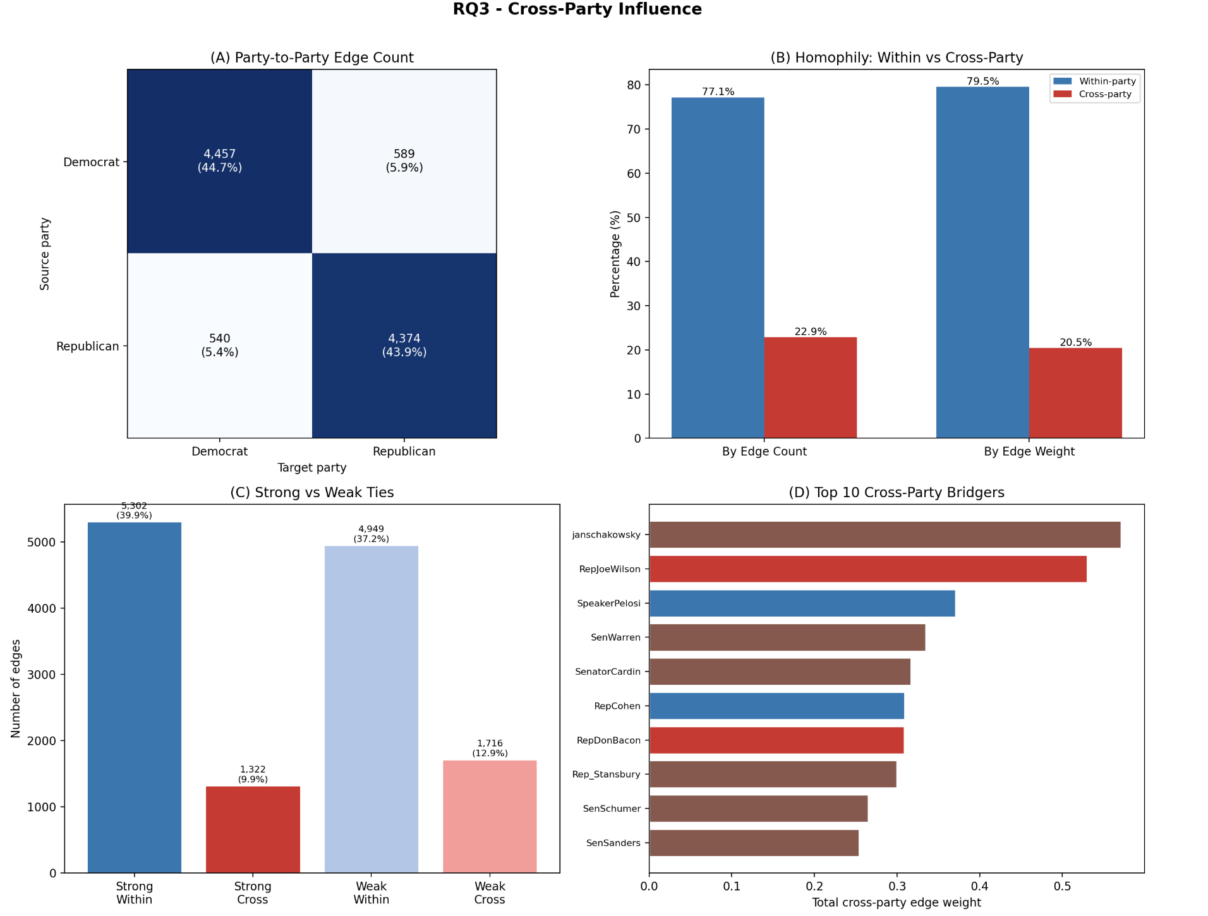
RQ3 Cross-Party
Figure 5 – RQ3 summary. (A) Party-to-party edge count heatmap (Democrat/Republican only). (B) Homophily: 77–80% of ties stay within party by both count and weight. (C) Strong ties are more partisan (80% within) than weak ties (74%). (D) Top 10 cross-party bridgers by total cross-party edge weight.

Egocentric Illustration: Two Modes of Influence
To make the cross-party dynamics concrete, we compared the ego networks of the top Republican influencer (SteveScalise) and the top Democrat influencer (SpeakerPelosi).
Metric | SteveScalise (R) | SpeakerPelosi (D)
Unique neighbors | 102 | 214
Out-degree | 89 | 210
In-degree | 63 | 51
Out-strength | 0.935 | 0.944
In-strength | 0.460 | 0.240
Same-party neighbors | 94.1% | 57.5%
Cross-party neighbors | 5.9% | 42.5%
Ego network density | 0.194 | 0.099

SteveScalise operates as an intra-party amplifier: 94% of his neighbors are Republican, and his ego network is dense (0.194), meaning his contacts are also heavily connected to each other. This creates an echo chamber where information circulates rapidly within a tight cluster.
SpeakerPelosi operates as a cross-party hub: 42.5% of her neighbors are from other parties, and her ego network is less dense (0.099), reflecting a broader but sparser web of connections. She broadcasts to more unique members (210 out-degree vs 89) but receives less engagement (in-strength 0.24 vs 0.46).

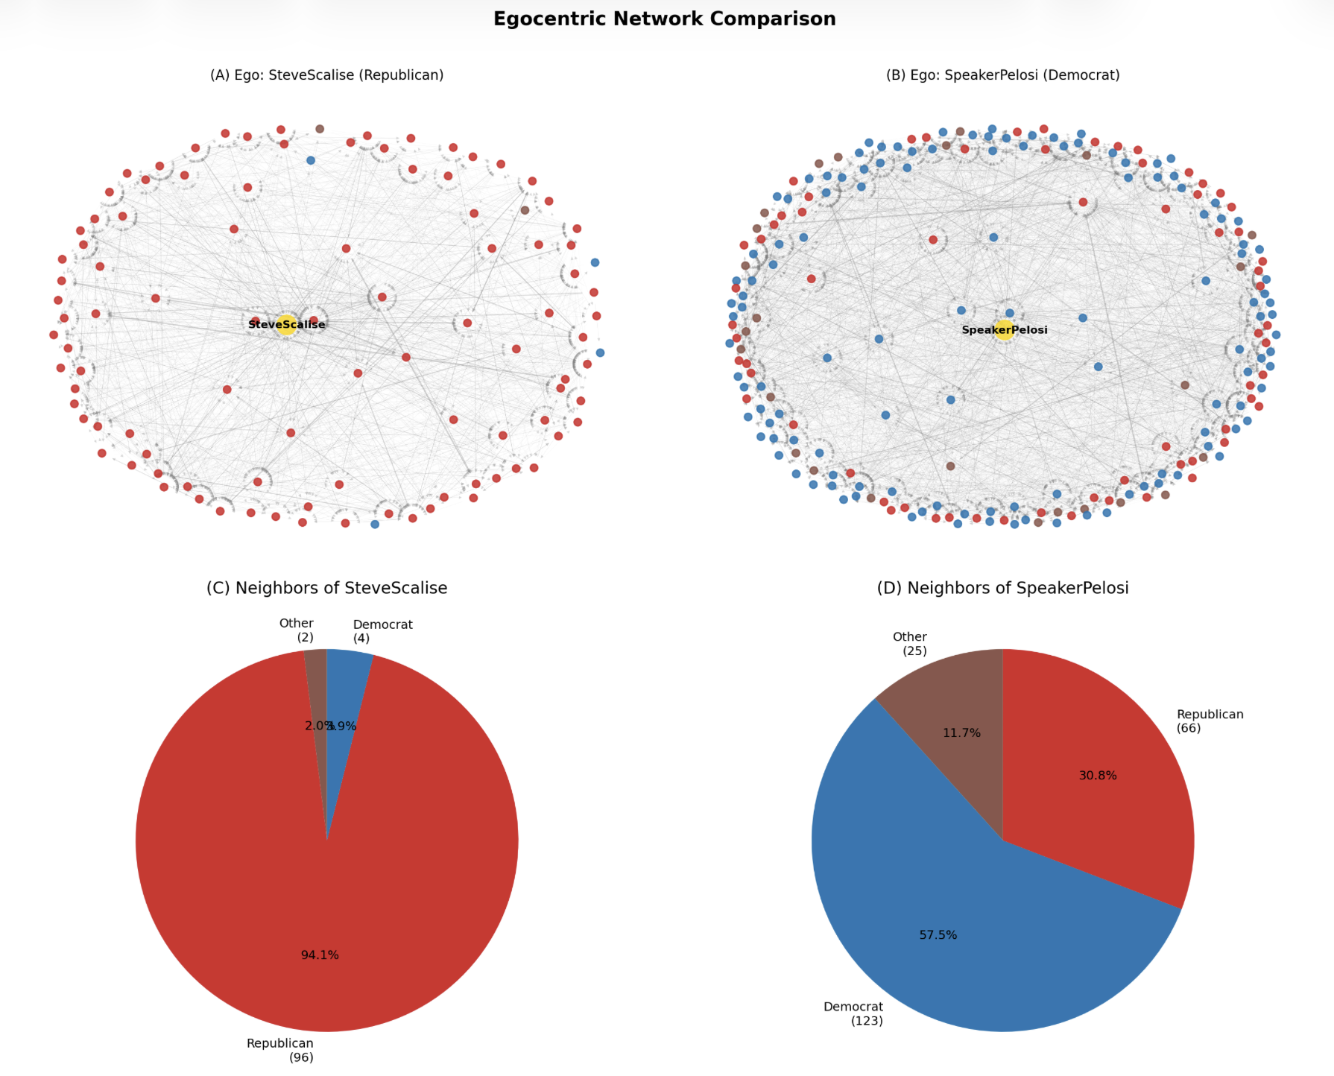
Egocentric
Figure 6 – Egocentric network comparison. (A-B) Ego network visualisations with edge thickness proportional to weight. (C-D) Neighbor party composition: Scalise’s network is 94% Republican; Pelosi’s spans 57.5% Democrat and 42.5% other parties.

RQ3 Conclusion: 1. The network is a partisan echo chamber: 77–80% of all influence stays within party, and strong ties are even more homophilous (80%). The Scalise ego network (94% same-party, density 0.194) typifies this intra-party clustering. 2. No articulation points exist – the network is structurally resilient, but cross-party flow depends on a small set of bridgers (RepJoeWilson, SpeakerPelosi). Pelosi’s ego network (42.5% cross-party) illustrates the cross-party hub role. 3. Cross-party flow is roughly symmetric between the two parties (589 vs 540 edges), suggesting neither side is significantly more outward-reaching than the other.

What-if Questions
What if we remove the top influencers? How does the network structure change, and what does this imply for each party?
Approach. We simulated three removal scenarios at 5, 10, and 15 nodes: - Scenario A: Remove top N influencers overall (by Viral Centrality). - Scenario B: Remove top N Democrat influencers only. - Scenario C: Remove top N Republican influencers only.
After each removal, we measured: largest SCC fraction, average path length, clustering coefficient, and density.
Key results (removing top 15):
Metric | Baseline | Remove 15 overall | Remove 15 Dem | Remove 15 Rep
Edges | 13,289 | 11,668 (-12.2%) | 11,947 (-10.1%) | 12,060 (-9.2%)
Largest SCC fraction | 98.7% | 98.5% | 98.5% | 98.7%
Avg path length | 2.35 | 2.41 (+2.6%) | 2.38 (+1.3%) | 2.39 (+1.7%)
Avg clustering | 0.301 | 0.277 (-8.1%) | 0.287 (-4.7%) | 0.289 (-4.1%)
Density | 0.059 | 0.055 (-6.3%) | 0.057 (-4.1%) | 0.057 (-3.2%)
SCC count | 7 | 8 | 8 | 7
Observations:
- The network is remarkably resilient. Even removing the top 15 influencers reduces the largest SCC by only 0.2 percentage points. No scenario fragments the network into disconnected communities.
- Removing top overall influencers has the strongest effect on clustering (-8.1%) and density (-6.3%), because these high-VC nodes have the most edges. But the structural backbone (SCC, path length) barely changes.
- Removing top Democrats has a slightly larger edge impact (-10.1%) than removing top Republicans (-9.2%) for the same number of nodes, consistent with Democrats’ broader connectivity (higher out-degree, more diverse ego networks). However, removing Democrats causes the diameter to decrease from 6 to 5 (the remaining network is more compact), while removing Republicans preserves the diameter at 6.
- Removing Republicans causes slightly less disruption overall, reflecting their tighter, more redundant internal structure: when one hub is removed, many alternative high-density paths exist within the Republican cluster.

Removed members:
Scenario | Top 5 removed
Overall | SteveScalise, SpeakerPelosi, RepBobbyRush, GOPLeader, RepJoeWilson
Top Dem | SpeakerPelosi, RepBobbyRush, RepMarkTakano, RepLucyMcBath, RepCori
Top Rep | SteveScalise, GOPLeader, RepJoeWilson, RepJamesComer, RepBobGood

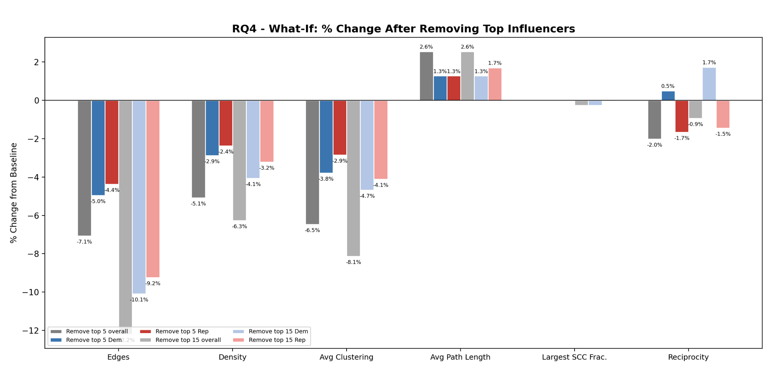
RQ4 What-If
Figure 7 – RQ4 summary. Percentage change from baseline across six metrics and six removal scenarios. Negative values indicate degradation. Edges and clustering suffer the most; SCC fraction barely changes.

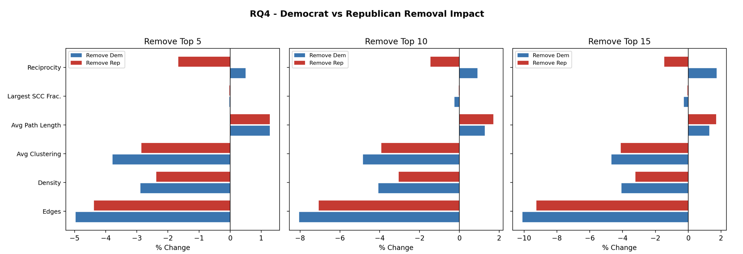
RQ4 Dem vs Rep
Figure 8 – Democrat vs Republican removal impact at each level (5, 10, 15 nodes). Removing Democrats causes more edge loss but increases reciprocity; removing Republicans causes less edge loss but decreases reciprocity.

RQ4 Conclusion: 1. No single set of removals fragments the network, confirming that Congressional Twitter influence is distributed, not hub-dependent. 2. Removing top Democrats causes more edge loss per node (broader connectivity), while removing top Republicans causes less disruption (tighter redundancy). Neither party’s network collapses. 3. Strategic implication: Both parties should invest in developing multipleinfluential voices rather than relying on a few leaders, as the network’s distributed structure means the loss of any individual has limited structural impact.

Implications
1. Echo chambers limit cross-partisan discourse.
With 77–80% of influence staying within party, Congressional Twitter functions primarily as an intra-party amplification system. Platform designers could identify members with low cross-party exposure and prioritise cross-partisan content recommendations. The bridging nodes identified in RQ3 (RepJoeWilson, SpeakerPelosi) represent the most efficient leverage points for increasing cross-partisan exposure.
2. Two types of influence require different communication strategies.
High-VC nodes (SteveScalise, RepBobbyRush) are powerful intra-community amplifiers but primarily reach their own party. High-betweenness nodes (GOPLeader, SpeakerPelosi) sit on cross-community shortest paths. A two-stage communication strategy would maximise reach: seed a message via a high-betweenness broker to cross party lines, then let high-VC nodes amplify within each community.
3. Distributed resilience has strategic implications for party organisations.
The what-if analysis shows neither party’s network collapses when leaders are removed. This distributed structure means that parties should invest in cultivating multiple influential voices across their caucus. Over-reliance on a single spokesperson creates reputational risk without corresponding structural advantage.

1. Echo chambers limit cross-partisan discourse
The extreme within-party homophily (88%) confirms that Congressional Twitter functions primarily as an intra-party amplification system rather than a cross-partisan debate platform. Platform designers could use network analysis to identify members with low cross-party exposure and prioritise cross-partisan content recommendations. The rare gatekeeper nodes (Fitzpatrick, Katko, Wilson) represent the most efficient leverage points: amplifying their content to the opposite party’s audience would produce the highest per-node increase in cross-partisan exposure.
2. Two types of influence require different communication strategies
The divergence between Viral Centrality and betweenness rankings has practical implications for political communication. High-VC nodes (Scalise, Rush) are powerful intra-community amplifiers but primarily reach their own party. High-betweenness nodes (GOPLeader, SpeakerPelosi) sit on more cross-community shortest paths. A two-stage communication strategy — seed the message via a high-betweenness broker to cross party lines, then let high-VC nodes amplify within each community — would maximise network-wide diffusion.

Conclusion and Limitation
<summarise key findings>
Research Question | Key Finding
RQ1: Community | Three cohesive party communities (4.9–8.3x density ratio). Republicans: tighter per-node connectivity. Democrats: broader inner-core presence. Out-degree centralisation (0.38) dominates over betweenness (0.07).
RQ2: Influence | Top influencers mirror real-world leadership. VC and out-strength are weakly correlated with in-strength (r=0.15). Republicans hold 70% of top-10 VC positions.
RQ3: Cross-party | 77–80% of edges are within-party. Strong ties are even more partisan (80%). No articulation points. Small set of bridgers connects communities.
RQ4: What-if | Network resilient to targeted removal. Removing 15 top nodes reduces edges by 9–12% but SCC barely changes. Both parties show structural redundancy.

<discuss the limitations in this work>

Limitations
- Temporal snapshot: 4 months of 2022; patterns may shift during elections or major legislative votes.
- Activity bias: members tweeting fewer than 100 times are excluded, over-representing highly active voices.
- No content analysis: edge weights capture frequency of interaction, not nature – a critical quote-tweet is treated identically to an endorsement.
- Missing metadata: 92 nodes lack party/chamber labels, grouped as “Other”. This inflates the Other community and may obscure some cross-party dynamics.
- Unweighted betweenness and closeness: these centrality measures were computed on hop count, not weighted distances, because the edge weights represent probabilities (higher = stronger), not distances. Inverting weights to use as distances would change the interpretation. We note this as a methodological choice, not an oversight.

Reproducibility
The analysis was conducted using Python and Gephi. In Python, the NetworkX library was used to convert the edgelist file provided by SNAP, to a Gephi compatible GEXF file.
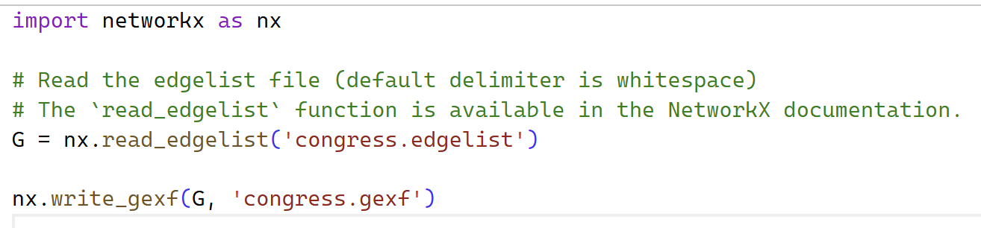
The script reads from edgelist file, constructs it as a graph, and writes the graph into a GEXF file.
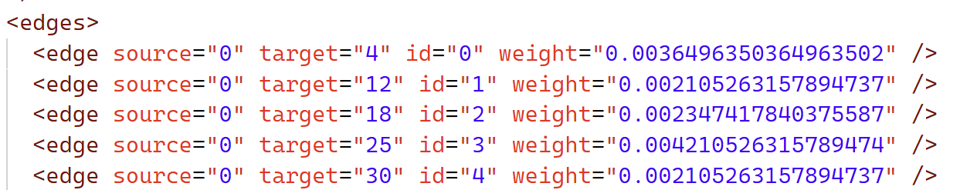
The resulting GEXF file retains edge information like direction and weight. The GEXF file is then imported into Gephi for network visualisation and analysis. Within Gephi, layout algorithms can be applied to better represent the structure of the network.

References
Fink, C. G., Omodt, N., Zinnecker, S., & Sprint, G. (2023). A Congressional Twitter network dataset quantifying pairwise probability of influence. Elsevier.
Fink, C., Fullin, K., Gutierrez, G., Omodt, N., Zinnecker, S., Sprint, G., & McCulloch, S. (2023). A centrality measure for quantifying spread on weighted, directed networks. Physica A.
Stanford University. (n.d.). SNAP: Network datasets: Twitter Interaction Network for the US Congress. Retrieved from SNAP: https://snap.stanford.edu/data/congress-twitter.html

Declare of AI tool usage

Appendix A
[NATIVE TABLE V2 — tblW + tcW fixed]

Full Centrality Table (Top 20)

Username | Party | Out-Deg | In-Deg | Out-Str | In-Str | Betweenness | Closeness | Eigenvector | VC
SteveScalise | Republican | 187 | 118 | 0.935 | 0.642 | 0.013 | 0.479 | 0.120 | 1.146
SpeakerPelosi | Democrat | 210 | 94 | 0.944 | 0.278 | 0.041 | 0.479 | 0.094 | 1.112
RepBobbyRush | Democrat | 173 | 113 | 0.869 | 0.374 | 0.027 | 0.464 | 0.111 | 1.007
GOPLeader | Republican | 195 | 127 | 0.827 | 1.648 | 0.073 | 0.476 | 0.267 | 0.980
RepJoeWilson | Republican | 153 | 82 | 0.695 | 0.255 | 0.005 | 0.459 | 0.085 | 0.810
RepJamesComer | Republican | 140 | 76 | 0.603 | 0.302 | 0.001 | 0.451 | 0.074 | 0.784
RepMarkTakano | Democrat | 151 | 107 | 0.650 | 0.271 | 0.002 | 0.455 | 0.073 | 0.781
RepBobGood | Republican | 133 | 74 | 0.541 | 0.197 | 0.001 | 0.447 | 0.066 | 0.687
RepCloudTX | Republican | 130 | 68 | 0.526 | 0.217 | 0.000 | 0.446 | 0.066 | 0.674
RepFranklin | Republican | 138 | 127 | 0.518 | 0.830 | 0.017 | 0.453 | 0.130 | 0.646
RepLucyMcBath | Democrat | 135 | 90 | 0.459 | 0.342 | 0.004 | 0.445 | 0.084 | 0.581
RepSpartz | Republican | 109 | 81 | 0.415 | 0.413 | 0.004 | 0.437 | 0.074 | 0.537
SenMikeLee | Other | 110 | 68 | 0.383 | 0.185 | 0.002 | 0.438 | 0.052 | 0.522
RepCori | Democrat | 114 | 79 | 0.424 | 0.233 | 0.003 | 0.442 | 0.067 | 0.516
VernBuchanan | Republican | 107 | 77 | 0.375 | 0.319 | 0.008 | 0.437 | 0.070 | 0.510
PatrickMcHenry | Republican | 106 | 91 | 0.377 | 0.527 | 0.009 | 0.436 | 0.089 | 0.500
RepJohnKatko | Republican | 107 | 78 | 0.358 | 0.303 | 0.004 | 0.436 | 0.063 | 0.476
RepRichHudson | Republican | 101 | 113 | 0.354 | 0.722 | 0.013 | 0.435 | 0.105 | 0.468
rosadelauro | Democrat | 110 | 68 | 0.395 | 0.198 | 0.002 | 0.441 | 0.061 | 0.466
replouiegohmert | Republican | 93 | 94 | 0.329 | 0.605 | 0.004 | 0.429 | 0.081 | 0.437

